 | CHAROTAR UNIVERSITY OF SCIENCE & TECHNOLOGY  DEVANG PATEL INSTITUTE OF ADVANCE TECHNOLOGY AND RESEARCH | 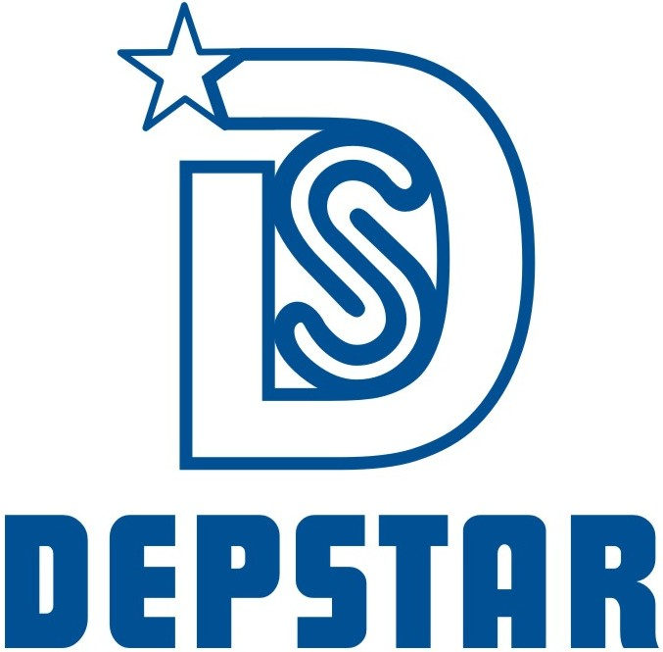

Weekly Report
In this report students require to mention the work has been done during the week and planning for the next week. (Please fill individual report for each week)

Student ID: 19DCS098 | Student Name: Parth Niteshkumar Patel
From Date: 21 June 2021 | To Date:27 June 2021
Semester: 4 | Internship ID: null

Work done in last week (Attach supporting Documents):

- Basics of Bootstrap

- Basics of Java Script

- Completed Section-6, Section-7, Section-8 and Section-9 of The Complete Web Development Bootcamp.

Projects Undertaken During Internship:

Total Projects Completed: 5

Projects given during current week: 2

Projects Completed during the current week: 2

Project Title:

- Make a simple gym website with form for becoming the member

- Make a notetaking website with the help of HTML, CSS, and javaScript.

Plans for next week:

- Basics of intermediate JavaScript
- Basics of DOM

References:

- The Complete Web Development Bootcamp
URL: https://www.udemy.com/course/the-complete-web-development-bootcamp/

- Instructor’s Session

Project Screenshots:

Project: GYM Website

Technologies Used: HTML, CSS

Description: It is a simple website that contains a form section where you can fill the necessary details

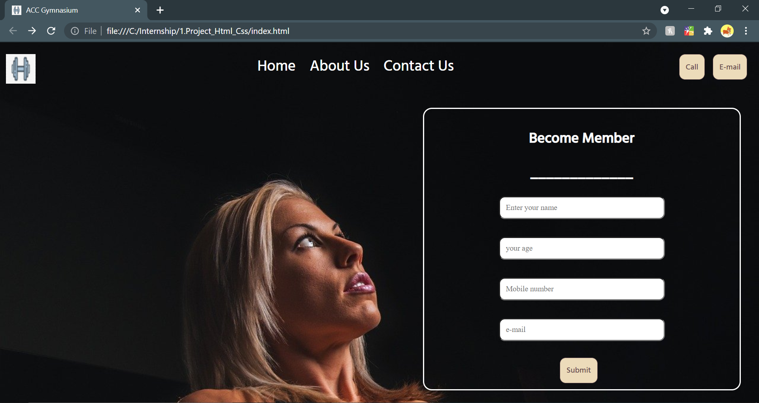

Project: Note Taking Website

Technologies Used: HTML, CSS and JavaScript

Description: It is a website where one can take notes and also can delete the notes. One can add title to the note also.

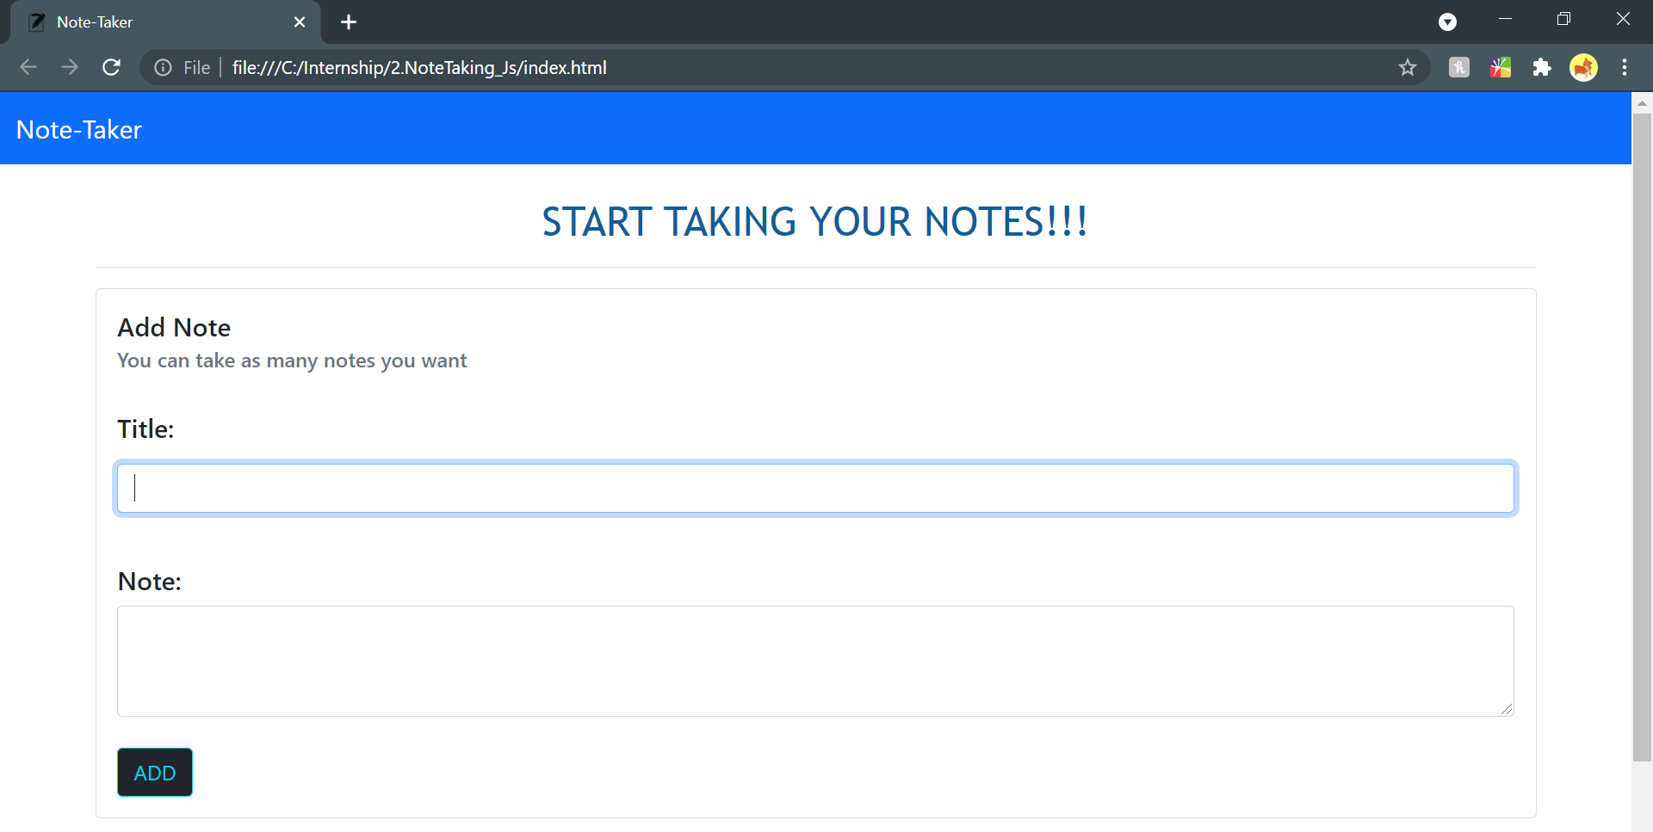

Section to add Notes

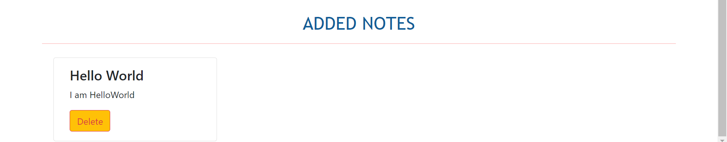

Note Added

Signature of External Supervisor Signature of Internal Supervisor



Note from Supervisor: The intern has completed the project 4 and project 5 successfully on time and the project has been verified.

